

Sultanate of Oman

Ministry of Higher Education

Rustaq College of Education

WEB SERVICE

ASSIGNMENT: STUDENTS

**Done By:**

Khulood Saleh AL-Handali 2014193097.

Sahar Said Alhabsi 2014193037.

### Submit to: MS: AYESHA RAZYA.

**CRUD**

**1-ADD(CREATE):**

localhost:9090/student/add?name=Khulood&email=2014193097&major=SOFTWARE

<http://localhost:9090/student/add?name=Sahar&email=2014193037&major=SOFTWARE>



**IN POSTMAN:**





**2-FIND ALL:**

[**http://localhost:9090/student/all**](http://localhost:9090/student/all)



**IN POSTMAN:**

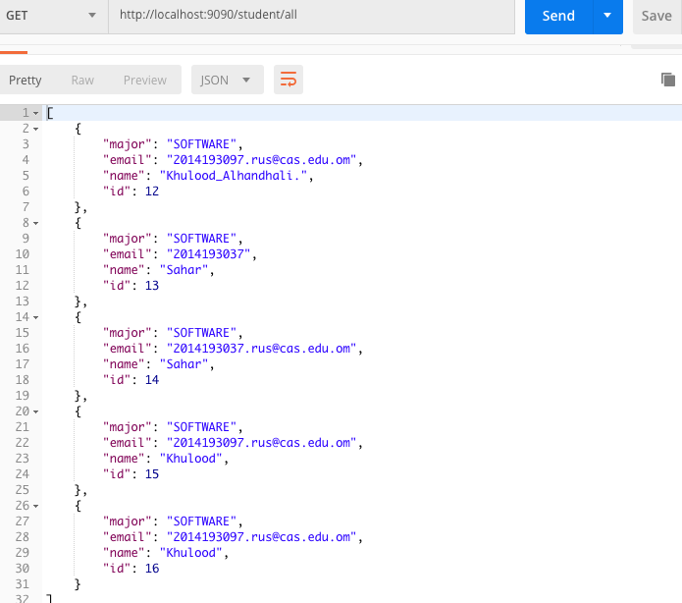

**3-FIND BY ID:**

[**http://localhost:9090/student/12**](http://localhost:9090/student/12)





**4-UPDATE:**

localhost:9090/student/update1?name=Sahar&email=2014193037.rus@cas.edu.om&major=SOFTWARE

<http://localhost:9090/student/update1?name=Khulood&email=2014193097.rus@cas.edu.om&major=SOFTWARE>

With **PUT** in Postman:

<http://localhost:9090/student/update/>

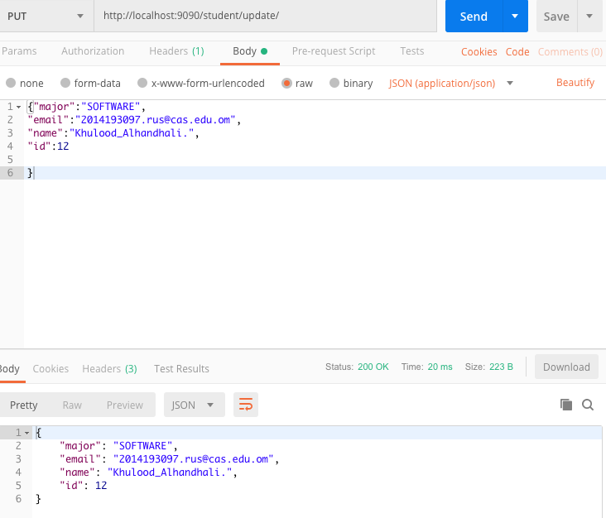



**5-DELETE in POSTMAN:**



BEFORE:

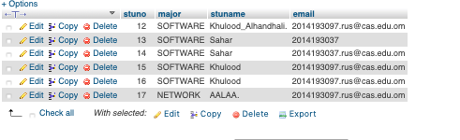

AFTER:



6-Getting Value from URI:

<http://localhost:9090/student/name?name=khulood&email=khulood@g.c&major=software>